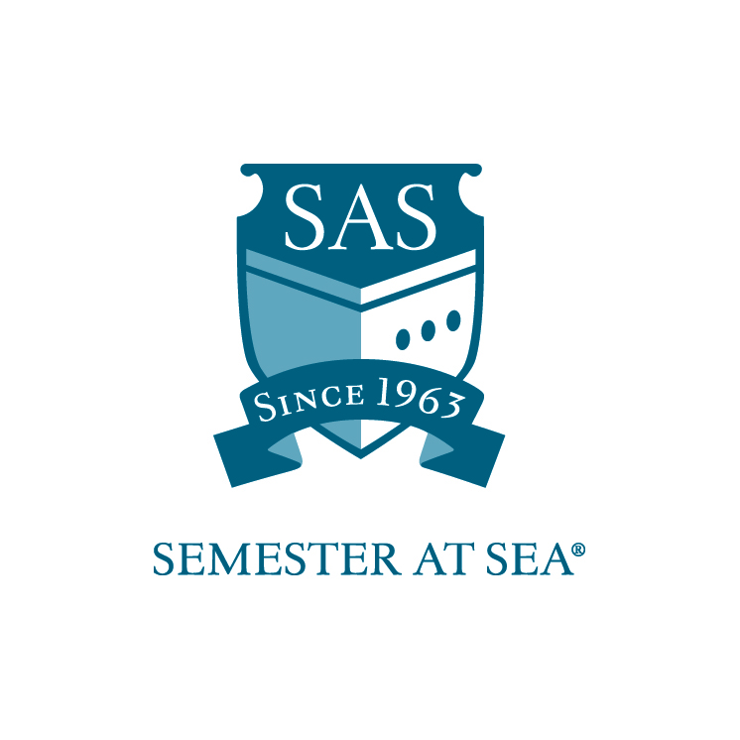
The Institute for Shipboard Education
Communications Team Work-Study Grant
Instructions and Application

*Note: Students with work-study positions traditionally board the ship one day prior to ship embarkation. Applicants should wait to make flight arrangements until after the award date.

This application is for students interested in a work-study position on the Communications Team aboard the MV Explorer. Students receiving this grant will be expected to work 2 hours every day while at sea. There will be no work expectations while in port. Students will also be expected to arrive one day before embarkation to assist the faculty and staff with pre-voyage preparation and student check-in. Work-study students hold an esteemed position within the shipboard community since they will have a special relationship with the faculty and staff onboard. With this award comes increased presence and responsibilities. As a result, recipients are expected to hold themselves to the highest standards when it comes to work performance and personal demeanor.

Students are expected to perform work duties as assigned by the Communications Coordinator, Photographer, Videographer or Assistant Executive Dean. Any student failing to perform duties as assigned may be removed from the position and required to reimburse ISE for hours not worked. Students may apply for the Videographer Assistant, Photographer Assistant, or Communications Coordinator Assistant position (see position descriptions below). Students may only apply for one work-study position.

Videographer Assistant

To be eligible for this position, students must:
- Have photo editing/videography experience using the Adobe Suite and Final Cut Pro
- Have experience in the Communications Field
- Submit a 1-2 minute sample of work (may be mailed or posted to YouTube)

Duties specific to the Videographer Assistant work-study position include:
- Assisting in loading footage, editing, creating titles, creating graphics, and loading content to web
- Assisting in authoring and burning DVDs
- Attending a daily meeting at sea; additional duties as assigned

Photographer Assistant

To be eligible for this position, students must:
- Have photo editing experience using the Adobe Suite
- Have experience in the communications field
- Submit a 1 – 2 minute sample slide show (may be mailed or posted to YouTube)

Duties specific to the Photographer Assistant work-study position include:
- Assist with digital image editing and production
- Assist with documentation during shipboard events
- Attending a daily meeting at sea; additional duties as assigned

Communications Coordinator Assistant

To be eligible for this position, students must:
- Major in Journalism, Communications or English
- Have experience at a newspaper, radio station or magazine
- Submit a copy of a press release (i.e. travel, campus life, etc.) – this can be one previously written or can focus on one of the countries on the itinerary.

Duties specific to the Communications Assistant work-study position include:
- Assisting in researching, writing, editing, proofreading, and producing/posting SAS promotional content for print and web
- Helping prepare press releases and public awareness materials
- Assisting with visiting members of the media and special guests
- Attending a daily meeting at sea; additional duties as assigned

___________________________________________________________

To be considered for one of the work-study positions please submit the following:
- Application (attached)
- Résumé
- Cover Letter
- Letter of Reference pursuant to this position
- Sample of work [if posted to YouTube, e-mail the URL to scholarships@isevoyages.org with the subject POSITION + VOYAGE (ie. Videographer Assistant Fall 2014)]

Applications must arrive in the ISE office by the due date listed for your voyage on the Semester at Sea web site.
Faxed applications will not be accepted.

Applications may be mailed to: PO Box 400885, Charlottesville, VA 22904
For Courier or Overnight Delivery: 2410 Old Ivy Road, Charlottesville, VA 22903
OR
Applications may be e-mailed to scholarships@isevoyages.org. Note: All application components should be condensed into one PDF file. Applications with more than one attachment will not be accepted.

Phone: 800/854-0195 Email: financialaid@isevoyages.org

The Institute for Shipboard Education
Communications Team Work-Study
Application

Name________________________________________________________

Voyage: Spring 20_____ Fall 20_____ Email_______________________

Desired Position_________________________________________________
*Note: You may only apply for ONE position. Please consider and choose the single position that you are most qualified for.

Section 1
Home School Information

Home School ___________________________________________________

Current cumulative GPA _____________

Please list any academic awards or honors:

_____________________________________________________________

_____________________________________________________________

_____________________________________________________________

Section 2
Work Experience

Please submit a résumé and cover letter along with your application. Address what specifically in your work history will prepare you for working on the Communications Team aboard the MV Explorer?

By signing below I hereby certify that all statements in this application and related materials are true. I authorize the Office of Financial Aid of the Institute for Shipboard Education to release my aid information to government agencies for reporting purposes.

Printed Name: ______________________________ Date: ________________

Signature: ________________________________

Applications must arrive in the ISE office by the due date listed for your voyage on the Semester at Sea web site.
Faxed applications will not be accepted.

Applications may be mailed to: PO Box 400885, Charlottesville, VA 22904
For Courier or Overnight Delivery: 2410 Old Ivy Road, Charlottesville, VA 22903
OR
Applications may be e-mailed to scholarships@isevoyages.org. Note: All application components should be condensed into one PDF file. Applications with more than one attachment will not be accepted.

Phone: 800/854-0195 Email: financialaid@isevoyages.org

