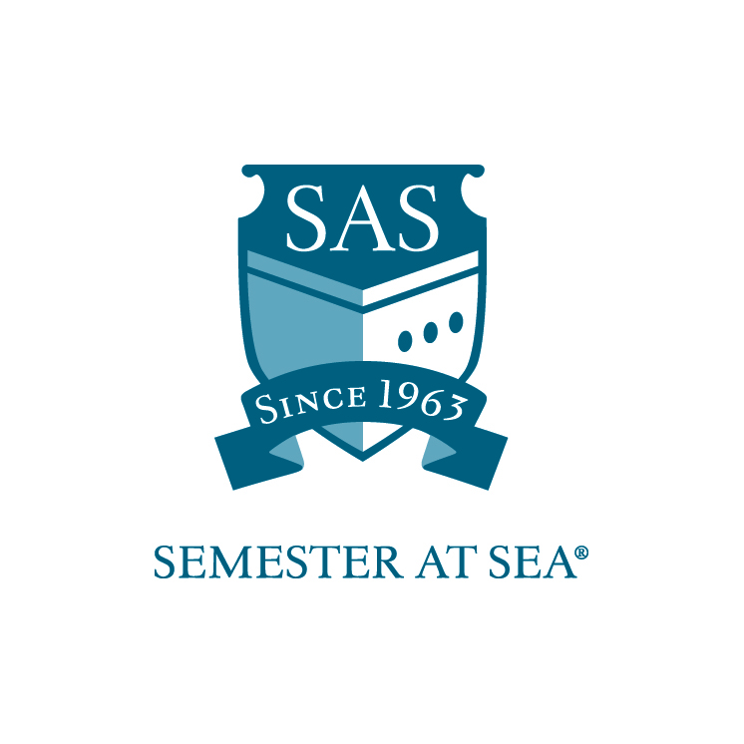
The Institute for Shipboard Education
Lifelong Learning Student Assistant Work-Study Grant
Instructions and Application

*Note: Students with work-study positions traditionally board the ship one day prior to ship embarkation. Applicants should wait to make flight arrangements until after the award date.

This application is for students interested in a work-study position as an assistant to the Lifelong Learning Coordinator aboard the MV Explorer. Students receiving this grant will be expected to work 2 hours every day while at sea. There will be no work expectations while in port. Students will also be expected to arrive one day before embarkation to assist the faculty and staff with pre-voyage preparation and student check-in. Work-study students hold an esteemed position within the shipboard community since they will have a special relationship with the faculty and staff onboard. With this award comes increased presence and responsibilities. As a result, recipients are expected to hold themselves to the highest standards when it comes to work performance and personal demeanor.

The Lifelong Learning Program Coordinator and Student Assistant are directly responsible for creating a cohesive community of Lifelong Learners that is integrated into the shipboard community by:
- Encouraging LLLs to participate in ship activities, to include: Staff/Lifelong Learner talent show; post-port open mike; pre-port skits; Extended Family program; Bridge Club; Exercise Club; Sea Olympics; presentation for Explorer Seminar; hosting sea social for extended families.
- Encouraging LLLs to be involved in academic programs (auditing courses, tutoring students, joining FDPs, etc.).

Students are expected to perform work duties as assigned by the LLL Coordinator. Any student failing to perform duties as assigned may be removed from the position and required to reimburse ISE for hours not worked. Students may only apply for one work-study position.

To be considered for the Lifelong Learning work-study position, please submit the following:
- Application (attached)
- Résumé
- Cover letter
- Letter of Reference
- 300-500 word essay on the following topic: What leadership qualities do you bring to the Lifelong Learning position?

Applications must arrive in the ISE office by the due date listed for your voyage on the Semester at Sea web site.
Faxed applications will not be accepted.

Applications may be mailed to: PO Box 400885, Charlottesville, VA 22904
For Courier or Overnight Delivery: 2410 Old Ivy Road, Charlottesville, VA 22903
OR
Applications may be e-mailed to scholarships@isevoyages.org. Note: All application components should be condensed into one PDF file. Applications with more than one attachment will not be accepted.

Phone: 800/854-0195 Email: financialaid@isevoyages.org

The Institute for Shipboard Education
Lifelong Learning Student Assistant Work-Study
Application

Name________________________________________________________

Voyage: Spring 20_____ Fall 20_____ Email_____________________________

Section 1
Home School Information

Home School ___________________________________________________

Current cumulative GPA _____________

Please list any academic awards or honors:

_____________________________________________________________

_____________________________________________________________

_____________________________________________________________

_____________________________________________________________

Section 2
Work Experience

Please submit a résumé and cover letter along with your application. Address what specifically in your work history will prepare you for working with the Student Life team aboard the MV Explorer.

Section 3
Essay

Submit a 300-500 word essay along with this application answering the following question:
- What leadership qualities do you bring to the Lifelong Learning position?

By signing below I hereby certify that all statements in this application and related materials are true. I authorize the Office of Financial Aid of the Institute for Shipboard Education to release my aid information to government agencies for reporting purposes.

Printed Name: ______________________________ Date: ________________

Signature: ________________________________

Applications must arrive in the ISE office by the due date listed for your voyage on the Semester at Sea web site.
Faxed applications will not be accepted.

Applications may be mailed to: PO Box 400885, Charlottesville, VA 22904
For Courier or Overnight Delivery: 2410 Old Ivy Road, Charlottesville, VA 22903
OR
Applications may be e-mailed to scholarships@isevoyages.org. Note: All application components should be condensed into one PDF file.
Applications with more than one attachment will not be accepted.

Phone: 800/854-0195 Email: financialaid@isevoyages.org

