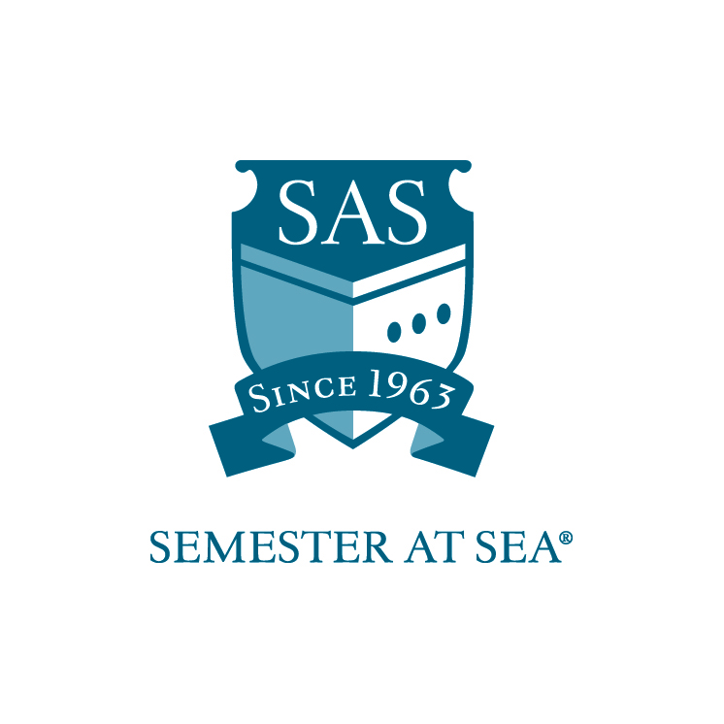
The Institute for Shipboard Education
Library Services Work-Study Grant
Instructions and Application

*Note: Students with work-study positions traditionally board the ship one day prior to ship embarkation. Applicants should wait to make flight arrangements until after the award date.

This application is for students interested in a work-study position in the library aboard the MV Explorer. Students receiving this grant will be expected to work 2 hours every day while at sea. There will be no work expectations while in port. Students will also be expected to arrive one day before embarkation to assist the faculty and staff with pre-voyage preparation and student check-in. Work-study students hold an esteemed position within the shipboard community since they will have a special relationship with the faculty and staff onboard. With this award comes increased presence and responsibilities. As a result, recipients are expected to hold themselves to the highest standards when it comes to work performance and personal demeanor.

Duties specific to the library services work-study position include:

- Shelving and cataloguing of books
- Inventory books and maps, both at the beginning and end of each semester
- Learn and maintain circulation database
- Staff the circulation desk and assist students and faculty as needed
- Special tasks as assigned by Librarian or Assistant Librarian

Students are expected to perform work duties as assigned by the Librarian, Assistant Librarian, or Assistant Executive Dean. Any student failing to perform duties as assigned may be removed from the position and required to reimburse ISE for hours not worked. Students may only apply for one work-study position.

To be considered for the work-study position, please submit the following:

- Application (attached)
- Résumé
- Cover Letter

Applications must arrive in the ISE office by the due date listed for your voyage on the Semester at Sea web site.
Faxed applications will not be accepted.

Applications may be mailed to: PO Box 400885, Charlottesville, VA 22904
For Courier or Overnight Delivery: 2410 Old Ivy Road, Charlottesville, VA 22903
OR
Applications may be e-mailed to scholarships@isevoyages.org. Note: All application components should be condensed into one PDF file.
Applications with more than one attachment will not be accepted.

Phone: 800/854-0195 Email: financialaid@isevoyages.org

The Institute for Shipboard Education
Library Services Work-Study
Application

Name________________________________________________________

Voyage: Spring 20_____ Fall 20_____ Email__________________________

Section 1
Home School Information

Home School ___________________________________________________

Current cumulative GPA _____________

Please list any academic awards or honors:

_____________________________________________________________

_____________________________________________________________

_____________________________________________________________

_____________________________________________________________

Section 2
Work Experience

Please submit a résumé and cover letter along with your application. Address what specifically in your work history will prepare you for working in the library aboard the MV Explorer?

By signing below I hereby certify that all statements in this application and related materials are true. I authorize the Office of Financial Aid of the Institute for Shipboard Education to release my aid information to government agencies for reporting purposes.

Printed Name: ______________________________ Date: ________________

Signature: ________________________________

Applications must arrive in the ISE office by the due date listed for your voyage on the Semester at Sea web site.
Faxed applications will not be accepted.

Applications may be mailed to: PO Box 400885, Charlottesville, VA 22904
For Courier or Overnight Delivery: 2410 Old Ivy Road, Charlottesville, VA 22903
OR
Applications may be e-mailed to scholarships@isevoyages.org. Note: All application components should be condensed into one PDF file.
Applications with more than one attachment will not be accepted.

Phone: 800/854-0195 Email: financialaid@isevoyages.org

