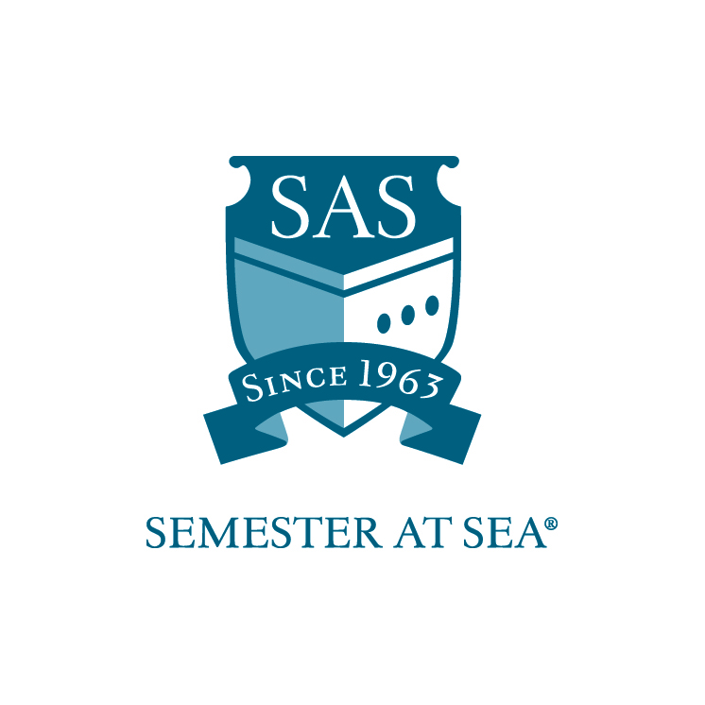
The Institute for Shipboard Education
Merit Grant
Financial Aid Application

This application is for students interested in merit-based financial assistance from the Institute for Shipboard Education (ISE). Only confirmed participants will be considered for financial aid. Please complete this application and return to the ISE office by the deadline indicated for your voyage.

Name_________________________________________________

Voyage: Spring 20_____ Fall 20_____

Email address ___________________________________________

Section 1
Academics

Home School ______________________________________

Current cumulative GPA _____________

Please list any academic awards or achievements:

_____________________________________________________________

_____________________________________________________________

________________________________________________________________________

_____________________________________________________________

Section 2
Leadership

List any leadership positions held or any recognition for leadership received:

_____________________________________________________________

_____________________________________________________________

_____________________________________________________________

_____________________________________________________________

Section 3
Short Answer

Respond to one of the following statements in 200 words or fewer:

- Describe your most meaningful achievement and how it relates to your participation and success on Semester at Sea.
- Describe a time in which you met failure, what you learned from it, and how it relates to your participation on Semester at Sea.

Section 4
Essay

Please submit an answer to one of the following questions with your application. The response should be between 400-600 words.

- Select a creative work -- a novel, a film, a poem, a musical piece, a painting or other work of art -- that has influenced the way you view the world and the way you view yourself. Discuss the work and its effect on you.
- Describe an event or idea in your intellectual life that has captured your curiosity or interest. How has it changed how you see the world?
- In the past years, we have seen an expansion of activity by international organizations, often at the expense of sovereign state autonomy. Write about your personal impression of this phenomenon.

By signing below I hereby certify that all statements in this application and related materials are true. I authorize the Office of Financial Aid of the Institute for Shipboard Education to release my aid information to government agencies for reporting purposes.

Printed Name: ______________________________ Date: ________________

Signature: ________________________________

Applications must arrive in the ISE office by the due date listed for your voyage on the Semester at Sea website.
Faxed applications will not be accepted.

Applications should be mailed to: PO Box 400885, Charlottesville, VA 22904
For Courier or Overnight Delivery: 2410 Old Ivy Road, Charlottesville, VA 22903

Applications may be e-mailed to scholarships@isevoyages.org.
Note: All application components should be condensed into one PDF file.
Applications with more than one attachment will not be accepted.

Phone: 800/854-0195 Email: financialaid@isevoyages.org

