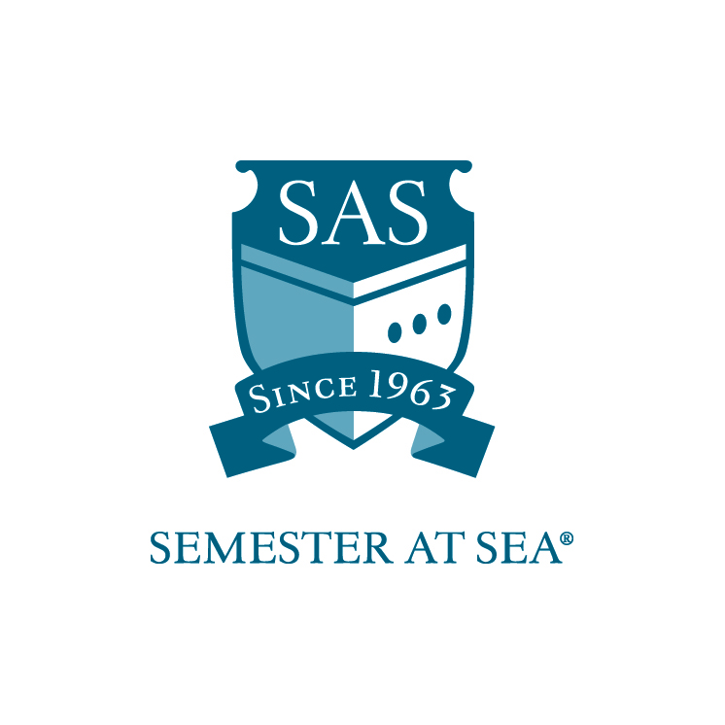
The Institute for Shipboard Education
Need-Based Grant
Financial Aid Application Instructions

This application is for students interested in need-based financial assistance from the Institute for Shipboard Education (ISE). Only confirmed participants will be considered for financial aid. Please complete this application and include the following:

- Signed copies of your custodial parents’ most recent federal tax returns (or an explanation if they will not file). We only require the first two pages of the 1040.
- Signed copies of your most recent federal tax returns (or an explanation if you will not file)
- Hard copy of your current Student Aid Report (SAR) – please make sure that you are sending all pages, including the page that contains your estimated family contribution (EFC).

International students - Please submit a statement of your parent's income with English translation and conversion to US dollars in lieu of the SAR and tax returns.

Applications must arrive in the ISE office by the due date listed for your voyage on the Semester at Sea website.
Faxed applications will not be accepted.

Applications should be mailed to: PO Box 400885, Charlottesville, VA 22904
For Courier or Overnight Delivery: 2410 Old Ivy Road, Charlottesville, VA 22903

Applications may be e-mailed to scholarships@isevoyages.org.
Note: All application components should be condensed into one PDF file.
Applications with more than one attachment will not be accepted.

Phone: 800/854-0195 Email: financialaid@isevoyages.org (questions only)

The Institute for Shipboard Education
Need-Based Grant
Financial Aid Application

Name____________________________________________________

Voyage: Spring 20_____ Fall 20_____

Email: ___________________________________________________

Section 1
Home School Information

Home School ______________________________________

Is your home school on a semester or quarter system? _____________

Current cumulative GPA _____________

Cost of an academic term (semester, quarter, or trimester) at your home school:

Tuition _______________________

Room and Board _______________________

Travel _______________________

Books _______________________

Personal Expenses _______________________

TOTAL _______________________

Section 2
Financial aid presently awarded at your home school: (Please list all aid, even if it is not transferable to Semester at Sea. If you have not yet been awarded for the year, please estimate)

Source Amount

______________________ ________________

______________________ ________________

______________________ ________________

______________________ ________________

______________________ ________________

Section 3

Do your parent(s) or guardian(s) claim you on their tax returns? ________________

If no, please explain_______________________________________________

_____________________________________________________________

Please note that ISE follows federal guidelines for considering the status of an independent student. A student must be a minimum of 24 years of age and/or meet federally defined criteria to be considered an independent. All other applicants MUST submit their parent or guardian’s 1040 tax forms to be considered for ISE financial aid.

Additional information you would like the committee to consider (Attach additional page if needed)

_____________________________________________________________

_____________________________________________________________

By signing below I hereby certify that all statements in this application and related materials are true. I authorize the Office of Financial Aid of the Institute for Shipboard Education to release my aid information to government agencies for reporting purposes.

Printed Name: ______________________________ Date: ________________

Signature: ________________________________

