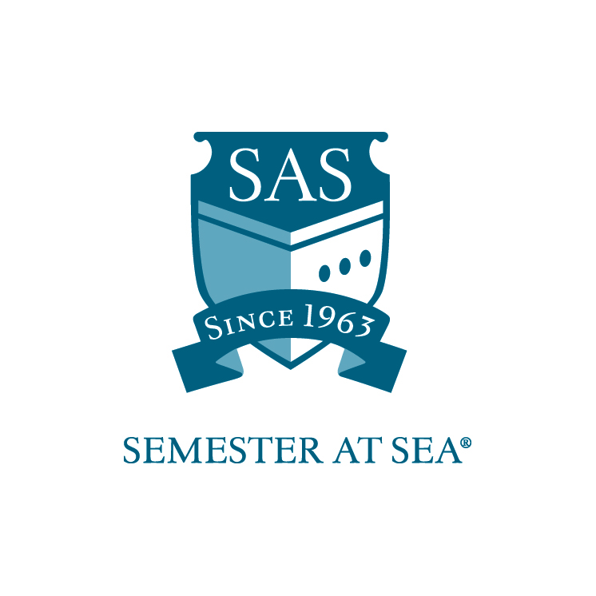
The Institute for Shipboard Education
Student Life Work-Study Grant
Instructions and Application

*Note: Students with work-study positions traditionally board the ship one day prior to ship embarkation. Applicants should wait to make flight arrangements until after the award date.

This application is for students interested in a work-study position in the Student Life Office aboard the MV Explorer. Students receiving this grant will be expected to work 2 hours every day while at sea. There will be no work expectations while in port. Students will also be expected to arrive one day before embarkation to assist the faculty and staff with pre-voyage preparation and student check-in. Work-study students hold an esteemed position within the shipboard community since they will have a special relationship with the faculty and staff onboard. With this award comes increased presence and responsibilities. As a result, recipients are expected to hold themselves to the highest standards when it comes to work performance and personal demeanor.

Students are expected to perform work duties as assigned by the Dean of Students, Assistant Dean of Students, or Resident Directors. Any student failing to perform duties as assigned may be removed from the position and required to reimburse ISE for hours not worked. Students may only apply for one work-study position.

To be considered for one of the Student Life work-study positions please submit the following:

- Application (attached)
- Résumé
- Cover letter
- Letter of Reference
- 300-500 word essay on the following topic: What leadership qualities do you bring to the Student Life position?

Applications must arrive in the ISE office by the due date listed for your voyage on the Semester at Sea web site.
Faxed applications will not be accepted.

Applications may be mailed to: PO Box 400885, Charlottesville, VA 22904
For Courier or Overnight Delivery: 2410 Old Ivy Road, Charlottesville, VA 22903
OR
Applications may be e-mailed to scholarships@isevoyages.org. Note: All application components should be condensed into one PDF file.
Applications with more than one attachment will not be accepted.

Phone: 800/854-0195 Email: financialaid@isevoyages.org

Student-Life Team Positions

The Student Life Team—together with the faculty—is responsible for the purposeful and holistic promotion for student learning and development that enhance the overall educational experience. The goals of the Student Life Team include:

- Promote programs and services that encourage the achievement of student learning and development outcomes
- Identify and find means to address individual, organizational, or environmental conditions that inhibit goal achievement
- Continuously improve programs and services in response to changing needs of students and other constituents, and evolving institutional priorities.

Student Life work study students may be asked to assist the Student Life Team with the following topics/positions:

- Career Development
- Community Standards
- Health and Wellness
- Intercultural Competence & Diversity
- Religion and Spirituality

- Community Service and Learning
- Recreation and Student Activities
- Academic Success

Career Development
The Resident Director and Student Assistant for Career Development are directly responsible for assisting students through all phases of their career development and helping students to develop job-search skills and competencies.

Community Standards
The Resident Director and Student Assistant for Community Service and Learning are directly responsible for engaging students in experiences that address human and community needs together with structured opportunities for reflection intentionally designed to promote student learning and development.

Health and Wellness
The Resident Director and Student Assistant for Health and Wellness are directly responsible for designing, implementing, and evaluating prevention, education, and wellness programs, services, and initiatives designed to advance the health of students and the entire shipboard community in an effort to enhance student learning and create a strong learning environment.

Intercultural Competence & Diversity
The Resident Director and Student Assistant for Intercultural Affairs and Diversity are directly responsible for promoting academic and personal growth of traditionally underserved students (this includes under-represented or oppressed students, such as students of color, lesbian, gay, bisexual and transgender students, and student with disabilities) and providing educational programs and services for all students that focus on: a) awareness of cultural differences, cultural commonalities, privilege, and identity; b) self-assessment of cultural awareness and possible prejudices; c) changing prejudicial, oppressive, and stereotypical attitudes or behavior.

Religion and Spirituality
The Resident Director and Student Assistant for Religion and Spirituality are directly responsible for providing access to programs that enable interested students to pursue full spiritual growth and development and to foster a campus atmosphere in which interested members of the shipboard community may freely express their religion, spirituality, and faith.

Community Service and Learning
The Resident Director and Student Assistant for Community Service and Learning are directly responsible for engaging students in experiences that address human and community needs together with structured opportunities for reflection intentionally designed to promote student learning and development.

Recreation and Student Activities
The Resident Director and Student Assistant for Recreation and Student Activities are directly responsible for enhancing students' fitness and wellness, knowledge, personal skills, and enjoyment by helping to provide opportunities for a variety of activities (ie. informal programs, intramural sports, sport clubs, interest groups, instructional programs, special events, etc.).
Academic Success
The Resident Director and Student Life Assistant for Academic Success are directly responsible for teaching students the skills and strategies to help students become independent and active learners and to achieve academic success.

The Institute for Shipboard Education
Student Life Work-Study
Application

Name________________________________________________________

Voyage: Spring 20_____ Fall 20_____ Email_____________________________

Section 1
Home School Information

Home School ___________________________________________________

Current cumulative GPA _____________

Please list any academic awards or honors:

_____________________________________________________________

_____________________________________________________________

_____________________________________________________________

_____________________________________________________________

Section 2
Work Experience

Please submit a résumé and cover letter along with your application. Address what specifically in your work history will prepare you for working with the Student Life team aboard the MV Explorer.

Section 3
Essay

Submit a 300-500 word essay along with this application answering the following question:
- What leadership qualities do you bring to the Student Life position?

By signing below I hereby certify that all statements in this application and related materials are true. I authorize the Office of Financial Aid of the Institute for Shipboard Education to release my aid information to government agencies for reporting purposes.

Printed Name: ______________________________ Date: ________________

Signature: ________________________________

Applications must arrive in the ISE office by the due date listed for your voyage on the Semester at Sea web site.
Faxed applications will not be accepted.

Applications may be mailed to: PO Box 400885, Charlottesville, VA 22904
For Courier or Overnight Delivery: 2410 Old Ivy Road, Charlottesville, VA 22903
OR
Applications may be e-mailed to scholarships@isevoyages.org. Note: All application components should be condensed into one PDF file.
Applications with more than one attachment will not be accepted.

Phone: 800/854-0195 Email: financialaid@isevoyages.org

