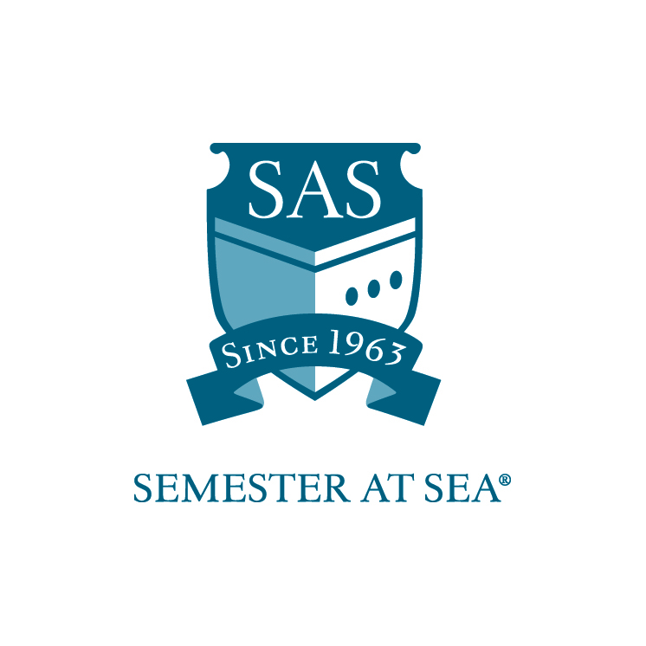
The Institute for Shipboard Education
Alumni Support Scholarship Application

The financial aid that Semester at Sea is able to award is made possible through the philanthropic support of SAS alumni. The majority of this aid comes from a general fund; however, we have an additional group of donors that set up specific scholarship funds. Students are expected to have a minimum GPA of 3.25 for consideration. Awarded students will be expected to maintain correspondence with the donors throughout the voyage.

Name___________________________________________________

Voyage: Spring 20____ Fall 20_____

Email ___________________________________________________

Section 1
Academics

Home School ______________________________________

Current cumulative GPA _____________

Please list all academic awards or achievements (continue on separate page if necessary):

_____________________________________________________________

_____________________________________________________________

________________________________________________________________________

_____________________________________________________________

Section 2
Leadership

List any leadership positions held or any recognition for leadership received (continue on a separate page if necessary):

_____________________________________________________________

_____________________________________________________________

_____________________________________________________________

_____________________________________________________________

Section 3
Essay

Please answer one of the following questions. Your response should be between 400-600 words.

- Which culture are you most passionate to learn more about on this voyage? What specific plans are you making to maximize that experience?

- Describe a cause or organization of which you are an alumnus and to which you feel immense ties. How have you or how would you plan on giving back to this cause? Please be specific.

Section 4
Student Aid Report

- Please submit a printout of your current Student Aid Report, available at www.fafsa.ed.gov.

By signing below I hereby certify that all statements in this application and related materials are true. I authorize the Office of Financial Aid of the Institute for Shipboard Education to release my aid information to government agencies for reporting purposes.
I also authorize ISE to release my contact information to an alumni donor if awarded a scholarship.

Printed Name: ______________________________ Date: ________________

Signature: ________________________________

Applications must arrive in the ISE office by the due date listed for your voyage on the Semester at Sea website. Faxed applications will not be accepted.

Applications should be mailed to: PO Box 400885, Charlottesville, VA 22904
For Courier or Overnight Delivery: 2410 Old Ivy Road, Charlottesville, VA 22903

Applications may be e-mailed to scholarships@isevoyages.org.
Note: All application components should be condensed into one PDF file. Applications with more than one attachment will not be accepted.

Phone: 800/854-0195 Email: financialaid@isevoyages.org (questions only)

