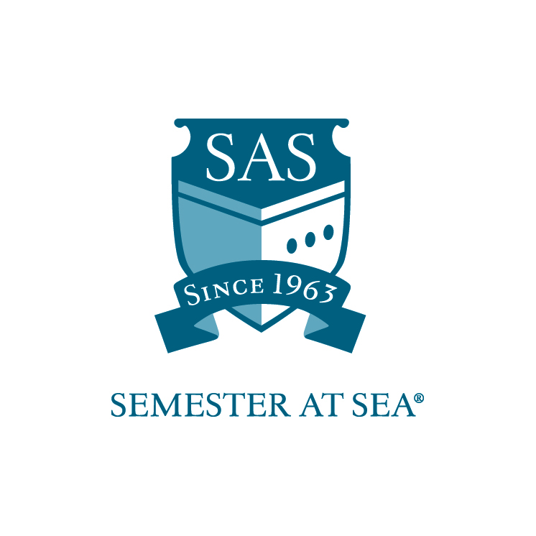
The Institute for Shipboard Education
International Student Advancement Award
Financial Aid Application

This application is for international students studying at universities outside the United States who are interested in financial assistance from the Institute for Shipboard Education (ISE).

Recipients of this award will be strongly encouraged to (1) conduct an Explorer Seminar on the ship and are required to (2) serve as a Global Ambassador on their home campus following their respective voyage.

Only confirmed participants will be considered for financial aid. Please complete this application and return to the ISE office by the deadline indicated for your voyage.

Name_________________________________________________

Voyage: Spring 20_____ Fall 20_____

Section 1
Academics

Home School ______________________________________

Current cumulative GPA _____________

Please list any academic awards or achievements (use an additional page).

Section 2
Leadership

List any leadership positions held or any recognition for leadership received (use an additional page).

Section 3
Short Answer

Respond to the following statements in 200 words or fewer:

- If there is one thing about your culture that you wish to share with fellow students on the voyage, what is it, and how would you go about doing so?

Section 4
Essay

Please submit an answer to the following statement with your application. The response should be between 400-600 words.

- Despite our ever-advancing international scene, there exist many barriers between cultures, such a language, politics, and more. What do you plan to do on the voyage that will bypass these barriers, creating a more inclusive environment amongst students of all backgrounds?

Section 5
Income Statement

- Please submit a statement of your parent's income with English translation and conversion to US dollars.

By signing below I hereby certify that all statements in this application and related materials are true. I authorize the Office of Financial Aid of the Institute for Shipboard Education to release my aid information to government agencies for reporting purposes.

Printed Name: ______________________________ Date: ________________

Signature: ________________________________

Applications must arrive in the ISE office by the due date listed for your voyage on the Semester at Sea website.

Applications may be mailed to: PO Box 400885, Charlottesville, VA 22904
For Courier or Overnight Delivery: 2410 Old Ivy Road, Charlottesville, VA 22903
Faxed Applications will not be accepted.

OR

Applications may be e-mailed to scholarships@isevoyages.org.
Note: All application components should be condensed into one PDF file.
Applications with more than one attachment will not be accepted.

Phone: 800/854-0195 Email: financialaid@isevoyages.org for questions.

